Load and Scalability with JMeter

To use Load & Scalability with JMeter

**Development Environment:**

* Apache JMeter 5.1.1 Version
* OpenJDK Runtime Environment 8.1

This guide has three sub-sections, namely:

1.1.1 Problem statement for Load & Scalability Testing in JMeter

1.1.2 Solution for the problem statement

1.1.3 Pushing the code to GitHub repositories

**Step 1.1.1** Problem statement for Load & Scalability Testing in JMeter

* Objective: Create Load & Scalability in JMeter for a particular domain.
* Steps involved:

1) Set Up JMeter.

2) Create a Test Plan.

3) Add Thread group.

4) Record the Scripts.

5) Add Https Cookies Manager.

6) Add Listener and view the results.

**Step 1.1.2** Solution for the problem statement

**1)** Set up a Thread Group:

* Right-click on Thread Group.
* Click on Add ->Thread Users -> Thread Group.

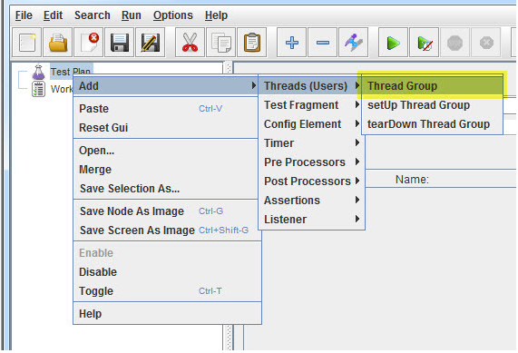

* Add the number of Thread Users.
* Add a ramp-up period.
* Add a loop count.

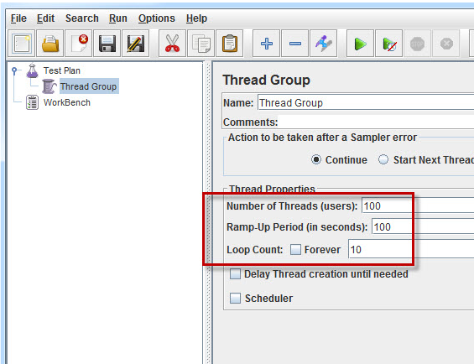

**2)** Add an HTTP Request:

* Right-click on Thread Group.
* Click on Add -> Sampler -> HTTP Request.

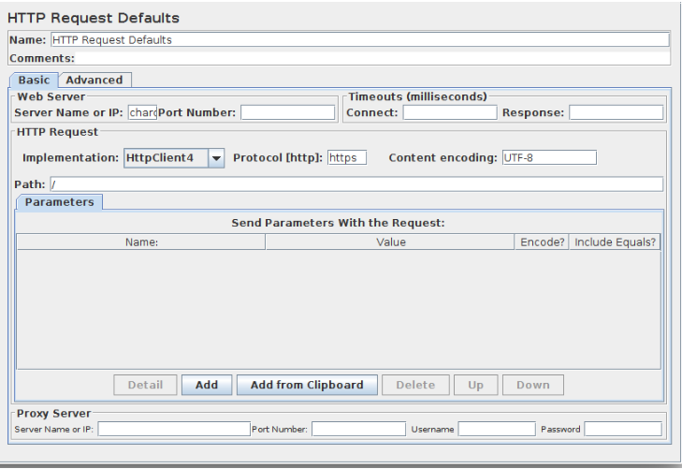

* Enter the IP Address.
* Enter the path.



**3)** Add the HTTP Cookies Manager:

* Right-click on Thread Group.
* Click on Add -> Config Element -> HTTP Cookie Manager.

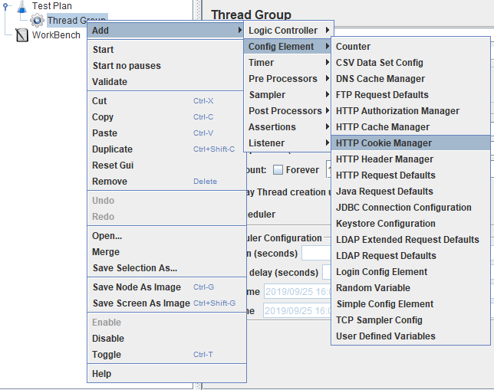

* Click on Add.
* Check if there is a credentials page.
* Enter the username and password.

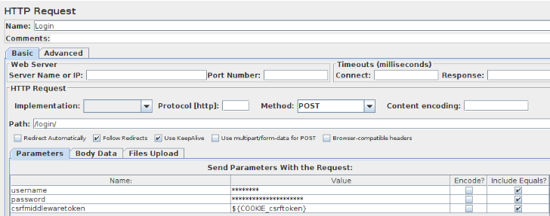

**4)** Add Listener to view the results:

* Right-click on Thread Group.
* Click on Add -> Listener -> View the result.

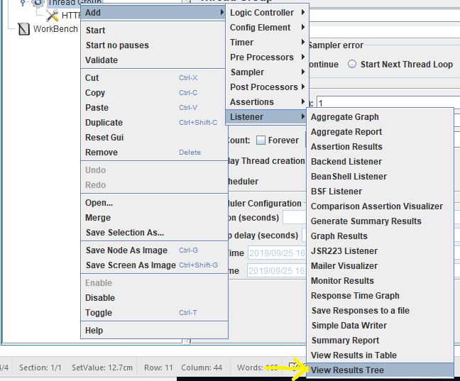

* Run the Scripts and view the results.

